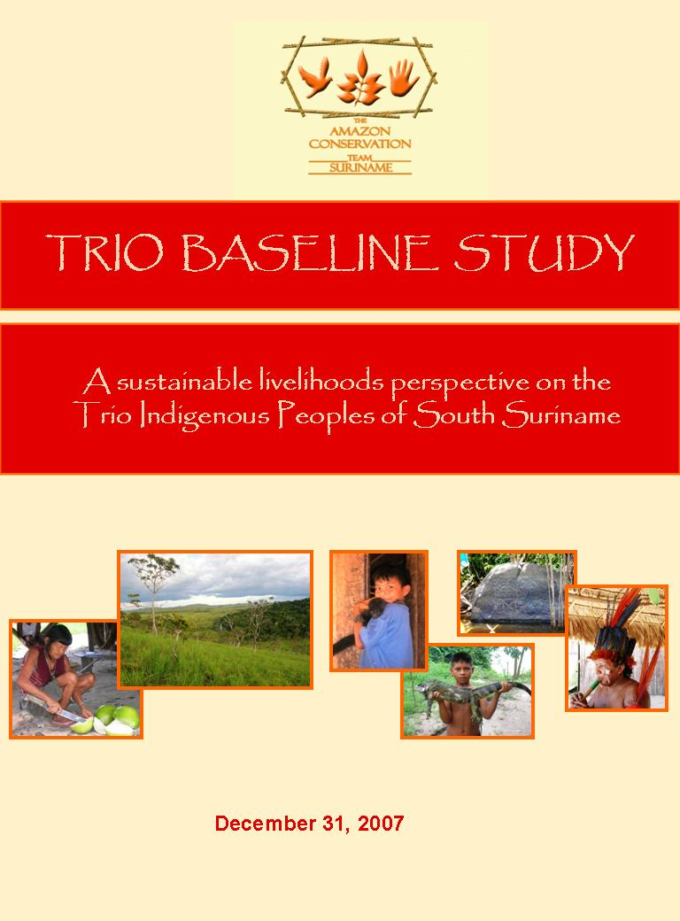

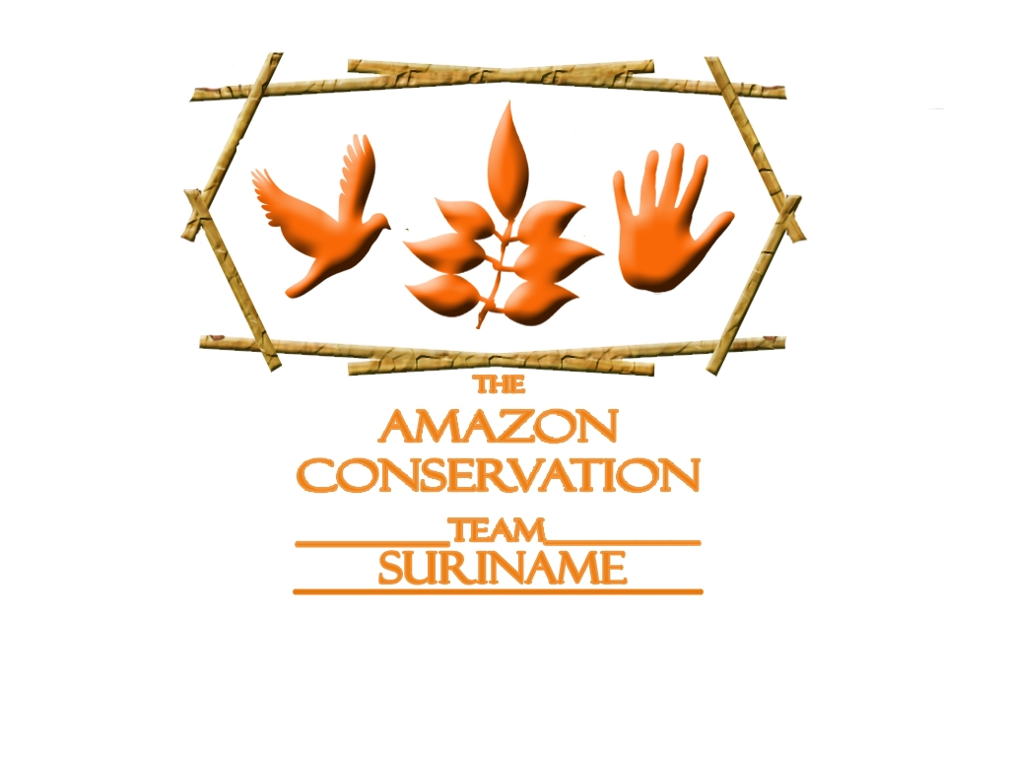

TRIO BASELINE STUDY

A sustainable livelihoods perspective on the Trio Indigenous Peoples of South Suriname

Final report
Paramaribo, 31 December 2007

By:
Marieke Heemskerk and Katia Delvoye, with the Trio communities

Copyright statement: The pictures, figures, and text in this report may not be duplicated without prior permission from Stichting Amazon Conservation Team-Suriname

ACKNOWLEDGEMENTS

The present study was commissioned by the Trio and Wayana Indigenous Organization TALAWA and the Amazon Conservation Team (ACT) Suriname.

We wish to thank numerous Trio villagers, traditional authorities, government officials, health workers, and members of Non-Governmental Organizations in Suriname for their time, insights, and information. A special word of thank is reserved for the community members of Wanapan, Sandlanding, Amotopo, Kuruni, Lucie, Kwamalasamutu, Sipaliwini, Alalapadu, and Tëpu for their hospitality and participation in the research. In particular we would like to thank our Trio surveyors for their excellent work and persistence in obtaining answers to often arduous questions: Cornelis, Marcel, and Tikinor from Tëpu; and Brian, Feikje, Seini, André, Jason in Kwamalasamutu. Many other Trios from the smaller places helped out as guides and translators in their respective home villages.

We are grateful to BHP Billiton Maatschappij Suriname (BMS) for providing TALAWA with the funds to command this study, and to the Organization of American States (OAS) for providing complementary funding to ACT.

Our gratitude also goes to the staff members of the ACT-Suriname for their help with logistics and information that helped understand the problems and development priorities of Trio families. TALAWA members and affiliates helped with travel arrangements, proper introductions to the communities, and information about the various villages and settlements that were visited. Thank you all!

Opinions expressed in this report are those of the author and do not necessarily reflect the views of ACT Suriname or other institutions the authors are affiliated with. The authors are responsible for all errors in translation and interpretation.

Marieke Heemskerk, Katia Delvoye, and the Trio communities

Paramaribo, Suriname
December 31st, 2007

LIST OF ABBREVIATIONS

ABS | General Bureau of Statistics (Algemeen Bureau Statistiek)
ACT | Amazon Conservation Team
ADEK | Anton de Kom University
AIDS | Acquired Immune Deficiency Syndrome
AOV | General Old-Age Services (Algemene Ouderdoms Voorziening)
CBL | Central Bureau Aerial Mapping (Centraal Bureau Luchtkartering)
CDFS | Community Development Fund Suriname
CI | Conservation international
CITES | Convention on International Trade in Endangered Species
DFID | Department For International Development
EBS | Energie Bedrijven Suriname
EES | Ethno-Ecological Study
FOB | Fonds Ontwikkeling Binnenland
GIAHS | Globally Important Ingenious Agricultural Heritage System
HIV | Human Immunodeficiency Virus
KITLV | Royal Institute for the Study of Language, Countries, and Peoples (Koninklijk Instituut voor Taal-, Land- en Volkenkunde)
LVT | Service for Aviation Grounds (Dienst Luchtvaartterreinen)
METS | Movement for Eco-Tourism in Suriname
MZ | Medical Mission primary Health Care Suriname
NARENA | National Resources and Environmental Assessment
NGO | Non Governmental Organization
NSI | North-South Institute
NVB | National Women’s Movement (Nationale Vrouwenbeweging)
OAS | Organisation of American States
PAHO | Pan American health Organisation
SIB | Foundation for Indigenous Peoples in Highland Suriname (Stichting Inheemsen Boven-Suriname)
SRD | Suriname Dollar
SRH | Sexual and Reproductive Health
STINASU | Stichting voor Natuurbehoud Suriname
SURALCO | Suriname Aluminum Company
TALAWA | Taren (Trio) and Wayana Foundation
UNDP | United Nations Development Program
USD | United States Dollars
WHO | World Health Organisation
WWF | World Wildlife Fund

SUMMARY

Study context

This report presents the results of an ethno-ecological baseline survey (EES) among the Trio Indigenous Peoples of Suriname, which was conducted between April and September 2007. The Trio EES was commissioned by TALAWA and Amazon Conservation Team-Suriname (ACT), with funding from the BHP Billiton (to TALAWA) and the OAS (to ACT). Its main objective is to:
Provide current, reliable data on the natural, human, social, financial, and physical capital features that characterize the Suriname Trio, in order to identify both vulnerabilities and opportunities that may either obstruct or facilitate the development of more sustainable Trio livelihoods.

The consultant, the indigenous organization TALAWA, hired an interdisciplinary research team to conduct fieldwork in the Trio communities of Sandlanding, Wanapan, Amotopo, Lucie, Kuruni, Kwamalasamutu, Sipaliwini, Alalapadu, and Tëpu. Using the sustainable livelihoods approach, the researchers collected data on physical, natural, social, human, and financial capital. Primary data obtained through surveys, open interviews, and field observations were complemented by secondary data from reports, maps, publications, and other sources.

Back ground

Suriname is located on the northern tip of South America. Its small and ethnically diverse population lives primarily in the coastal zone. The forested interior, which covers 80% of the country, provides sustenance to Indigenous Peoples and Maroons. These interior regions are marginalized in their access to public services such as education, health care, clean water, electricity, and communication networks.

The Trio occupy a large area in the northern Amazon Region, on both sides of the Suriname-Brazil border. In Suriname, the Trio live in the upper Sipaliwini-Corantijn River basin and the Tapanahoni-Palumeu River basin. They have no formal rights to these lands though, which leaves them vulnerable in the face of large-scale resource exploitation schemes by the Government of Suriname and private industry.

The Trios probably moved from Brazil to Suriname around the late 17th century. By the first half of the 20th century, introduced diseases led to rapid decreases in population numbers. In the 1960s, Baptist missionaries convinced the Trio to live in larger population centers where they were given health care and missionary education. This transition caused dependency on manufactured goods, the loss of traditional knowledge, and the over-extraction of selected natural resources. In recent years, Trio Granman Asongo has been motivating his people to disperse again.

Presentation of field data: Five capital types

Natural capital refers to natural resources, such as the forest with its flora and fauna, sources of fresh water and mineral resources. The majority of the study area is occupied by rocks of the Trans Amazonian granoit-volcanic complex. Other than most of Suriname, the Trio area has only one dry and one rainy season. Landscape characteristics and the presence of fresh water rivers determine the location of Trio settlements. The vegetation is dominated by lowland forest. Other vegetation types in the Trio-area are floodable forest, secondary forest, liana forest, mountain forest and savanna related vegetation.

The list of most frequently used plants among the Trio is lead by palms, which are used for roofing thatch and for their fruits. Other trees and plants provide material for the construction of houses and shelters, furniture, canoes, paddles, twining rope, hunting and fishing gear, weapons, food, medicines, body care, and other uses. Forest fruits, nuts and honey supplement to the Trios’ diet. The Trio rarely use plants for commercial purposes.

Hunting and fishing occur year-round but are seasonal for some animals. The favorite hunting weapon is the shotgun; other used methods are the bow and arrow, traps, or catching by hand. Fishing occurs mostly with a long land line and nylon fishing nets. As animal husbandry is rare, bush meat and fish are the main sources of dietary protein. Animal parts also are used for tools, utensils and musical instruments. In various villages, hunters and fishers sell fresh fish, bush meat, and live animals. Prices paid to the trappers are low.

The Trio area hosts several protected plants and animals that are listed internationally as threatened or endangered, and many among them are rare or endemic to the Guiana Shield. Two nature reserves are present in the area to protect wildlife and their forest habitat: the Sipaliwini Nature Reserve and the Central Suriname Nature Reserve.

The Trio farming system is based upon shifting cultivation with a high agricultural biodiversity. The most important staple crop is cassava, which is planted alongside other staples, vegetables, and fruits. The Trio also grow fruits and utility crops in the vicinity of their houses. Agricultural plots are selected for accessibility, drainage conditions, the absence of leaf cutting ants, soil texture, and flatness. Leaf-cutting ants and agouti are the most damaging agricultural pests, followed by other mammals and some birds. Traditional knowledge of fauna and flora and ecological practices are at risk of being lost.
.
Human capital includes the skills, knowledge, ability to work, and good health that enable people to pursue livelihood strategies. The ‘Trio’ are a conglomerate of more than 15 sub-groups who to a large extend share a history, culture, and language. In addition, non-Trio individuals such as Akuryo and Waiwai live in Trio villages. An estimated 1492 Trios live in Suriname (excl. Paramaribo and Palumeu), in 341 households. The average Trio woman has given birth to 3.5 children. Trio household (av. 4.25 p.) are typically larger than those in Sipaliwini district and those in Suriname as a whole.
Only two elementary schools are found in the Trio area; in Kwamalasamutu and Tëpu. Children from Wanapan and Sandlanding attend school in Apoera, children in Sipaliwini are occasionally taught in a makeshift community-school, and children in other villages do not go to school at all. The existing schools are short of qualified teachers and writing materials. Educational achievement in all Trio villages is relatively low. Male and female heads of household have, on average, attended school for 2 to 3 years and most do not speak the national language. Many obstacles -including the language barrier, poorly educated parents, and corporal punishment at the schools- make that most children double classes and/or drop out. There are no opportunities to attend secondary education in the Trio area and also practical training courses are extremely limited.

The Medical Mission Primary Health Care – Suriname (Medische Zending- MZ) has clinics in Kwamalasamutu, Tëpu, Sipaliwini, Kuruni, and Alalapadu. People from Wanapan, Lucie, and Amotopo travel a day to reach the nearest health post – provided there is a boat, an outboard motor, and fuel. Population health appears to be reasonable. The main health problems are malaria; colds/flue; diarrhea; poor nutrition; and infections. Sexual and reproductive health is threatened by unsafe sexual practices leading to early teen pregnancies, unsafe abortions, and a high risk of HIV/AIDS transmission.

When the Trios were converted to Baptism, the Shamans’ central role in society withered. Today alarmingly few people in the Trio communities know how to make forest medicines. ACT’s shaman’s apprentice program in Kwamalasamutu (2000) and Tëpu (2001) promotes the preservation of traditional medicinal knowledge.

Social capital refers to social networks and norms, organizational and institutional structures, migratory networks, and safety nets. The Trio are poorly represented in national government structures. The tribal authorities - Granman, Kapitein, and Basja- receive a public honorarium and are accountable to the national government. However, their functions and powers are not defined or endorsed by law.

In the absence of a strong public social security system, community members take care of the most vulnerable groups in society. In the most acculturated villages, such as Kwamalasamutu, however, traditional caring and sharing systems are making place for a greater degree of individualism. Neither the Suriname government nor the Trio communities have strategies in place to cushion the effects of region-wide disasters. In 2006 and 2007, NGO’s, the Suriname government and Trios collaborated to help Trio families that experienced acute food shortages due to flooding. Most help focused on emergency relief, however, and did not improve food security in the long run.

The Trio are organized in the regional foundation TALAWA and part of several national indigenous organizations. Communication between any of these organizations and the common Trio people is limited. Few communities have active Community-Based Organizations (CBO). Crime is virtually non-existent in the smaller Trio settlements. In Kwamalasamutu, petty theft, drugs use and trade, and prostitution are on the rise. Domestic violence and sex crimes (e.g. sexual molest or rape) are quite common yet not recognized as crimes. In the absence of national law enforcement agents, the traditional authorities decide on guilt and punishment. A team of indigenous park rangers helps maintain order in Kwamalasamutu since 2007.

Migration data shows that despite their concentration since the 1960s, Trio families continue to move around to either temporarily or permanently live in another community.

Financial capital represents (sources of) cash money and other valuables. Financial infrastructure in the form of banks is absent in the Trio area. As wage labor jobs are rare, most Trio families rely on the natural environment for cash income. They make traditional handicrafts (mostly women); sell birds, frogs and snakes (primarily Sipaliwini and Tëpu); sell bush meat and fish (Wanapan and Sandlanding); and work in the gold mines along the Lawa river. The main non-resource related source of income is wage labor, with the government being the main employer. Other jobs include sale and resale of consumer goods, work with NGOs, and Brazil nuts harvest (Alalapadu).

Trios spend most of their earnings in Paramaribo. Corantijn Trios most frequently visit the coastal area. An analysis of asset ownership suggests that households in Tëpu and Sipaliwini, which are actively involved in the animal trade, are relatively wealthiest. Relatively poorest are the families from Sandlanding and Wanapan.

Private enterprises active in the Trio area focus on tourism and mining. (Eco)tours visit Sipaliwini, Kwamalasamutu, Amotopo, and Wanapan, but Trios are barely involved and earn little from them. Gold is not yet exploited in the Trio area. The projected construction of a large-scale bauxite mine in the Bakhuys area is not likely to affect the Southern Trio communities, but Sandlanding may experience noise and air pollution from a nearby harbor facility. If the Government of Suriname executes its plans for an ‘integrated bauxite industry’, which relies on electricity from a hydropower plant in the Kabalebo watershed, especially the Corantijn villages would be severely impacted.

Active donor and development organizations in the Trio area in 2006-2007 include CDFS, PAHO/WHO, ACT, CI, UNDP, Global Fund, and SIB. These organizations have provided financial, logistic, and other relevant support for the execution of projects in the target areas of health, education, income generation, and biodiversity conservation.

Physical capital comprises physical infrastructure such as roads, structures, and physical assets in the communities. Apart from Sandlanding, no Trio village can be reached by road Access is provided by plane or by boat. The Trio territory also is out of reach of telecommunication networks, newspaper selling points, and radio- and TV broadcasting.

Trio houses are usually built of natural materials. The Suriname Water Company (SWM) does not service the Trio communities. Instead families rely on rain water and on rivers and creeks. Currently a water system is built by the community of Kwamalasamutu with help from ACT. Sanitary conditions are unhygienic throughout the study area. The shared outhouses tend to be dirty, and almost everyone uses the river or the forest for defecation. Also the Energy Company of Suriname (EBS) does not reach the Trio. Only the village of Tëpu has a working community generator from the government. However, often there is no fuel and not all houses are connected. In the remaining villages people have to fend for themselves. Better-off households own private generators (13.5 %) or solar panels (4.8 %).

Apart from a selected few elderly, few Trios still wear their traditional dress and ornaments. Traditional jewelry continues to be popular among woman and men.

Synthesis

Identified vulnerabilities, problems and risks include:

Natural capital:
- Increasing need for cash leads to wildlife (and plant) trade.
- Poor preparedness for extreme weather events and other natural disasters.
- With population growth in the largest Trio settlements, extraction levels may exceed the forest’s carrying capacity locally.
- Loss of ancient knowledge of use of surrounding fauna and flora.
- Need for a changing ecosystem management due to extern influences.
- The lack of land rights/titles for Indigenous individuals and communities.

Human capital:
- Poor or no access to basic education for Trio children.
- Threats to sexual and reproductive health, including unsafe abortions, early teen pregnancy, and high-risk sexual behavior.
- Lack of access to health facilities in some of the communities.
- Loss of traditional cultural knowledge of, among others, music, dance, and stories.

Social Capital:
- Limited representation within the Central Government of Suriname.
- Functions and powers of the traditional authorities within the national political and legal systems are undefined and unclear.
- Low level of community-based organization.
- Rise of criminal behavior - theft, drugs use, prostitution, rape- in Kwamalasamutu.
- Virtual absence of sports and leisure facilities for youth.
- Lack of national and community based systems to cushion household shocks.

Financial capital:
- No access to national financial infrastructure obstructs small business development.
- Heavy reliance on the natural environment for income.
- Dependency on outsiders for income from Brazil nut production and tourism.
- Possible construction of a hydropower facility will flood a large part of the Trio traditional homelands, including villages.
- Donor assistance can create passivity and discourage self-help initiatives.

Physical capital:
- Isolation; no connection to roads or communication and information networks.
- Lack of reliable sources of electricity and drinking water.
- Unhygienic sanitary conditions.

The researchers identified a variety of opportunities, capacities, and resources to overcome these negative forces and develop more sustainable livelihoods:

Natural capital:
- Abundance of forest resources, including a range of Non Timber Forest Products (honey, Brazil nuts, oils, fruits, crafts, medicinal plants).
- ACT’s Shaman’s apprentice program.
- Well considered and sustainable eco-tourism activities.

Human capital:
- Widespread literacy.
- Presence of Trios with some education and knowledge of Dutch, who could serve as teachers in community schools.
- Generally good health; low HIV- prevalence rates.
- Knowledge of medicinal plants and traditional healing practices still present among shamans and elders.
- ACT supports the preservation of traditional cultural and medicinal knowledge.

Social capital:
- The Trio are becoming more vocal in national politics.
- Establishment of TALAWA to represent the interests of the Trio and Wayana in national policy making and other national level affairs.
- Overall low crime rate.
- Establishment of a park rangers unit may help fight crime in Kwamalasamutu.
- Socialization at kasiri parties and in church strengthens social cohesion, which in turn is crucial in the maintenance of social safety nets.

Financial capital:
  - NTFPs provide opportunities for sustainable income generation, e.g. Brazil nuts.
  - Ecotourism has a potential to provide more direct and indirect income to Trios.
  - Bakhuys project may provide employment to the villagers of Sandlanding.
  - More frequent travel to the city can be used for the marketing of crafts.
  - A variety of donor organizations is willing to invest in the Trio area.

Physical capital:
- Existence of foot paths that link the different Trio villages.
- Throughout the Trio territory people are skilled in building traditional homes.
- Many adults still have knowledge to make and wear the traditional dress.
- Construction of a water system in Kwamalasamutu.
TABLE OF CONTENTS

Acknowledgements | 1
List of Abbreviations | 2
Summary | 3
Table of Contents | 9
Chapter 1. Introduction | 13
1.1 Prelude | 13
1.2 Study aims and objectives | 14
1.3 Study approach | 15
1.4 Beneficiaries | 15
1.4.1 TALAWA | 15
1.4.2 Amazon Conservation Team | 16
1.4.3 BHP Billiton Maatschappij Suriname | 16
1.4.4 Organization of American States | 16
1.4.5 Other beneficiaries | 16
1.4 Lay-out | 17
Chapter 2. Methodology | 18
2.1 Research site | 18
2.2 Research Framework: Sustainable Livelihoods Approach | 18
2.3 The Consultant | 20
2.4 Time table and location of activities | 20
2.5 Methods used for primary data collection | 21
2.5.1 Social science data | 21
2.5.2 Ecological data | 22
2.6 Methods used for secondary data collection | 23
2.7 Data analysis | 23
2.8 Research logistics | 24
2.9 Challenges | 24
Chapter 3. Study Location | 26
3.1 Suriname | 26
3.1.1 Natural environment and geophysical conditions | 26
3.1.2 Population | 27
3.1.3 Economy | 28
3.1.4 Politics | 29
3.2 Trio Territory | 30
3.2.1 Trio Peoples in the larger Amazon basin | 30
3.2.2 Trio communities in Suriname | 31
3.3.3 Territorial rights and frontiers | 33
Chapter 4. History of Trio Settlement in Suriname | 34
4.1 The first Indigenous populations in Suriname, + 8,000 – 4,000 BC. | 34
4.2 The development of early tropical forest cultures, + 4000 BC – 1600 AD | 35
4.3 Trio settlement in South Suriname | 35
4.4 Early colonial period, 1600-1700 AD | 36
4.6 1796-1950s: Meeting European explorers | 36
4.6 Organization grasshopper and missionary activity | 37
4.6 The interior war | 38
4.7 Acculturation and change | 39

Chapter 5. Natural capital | 40
5.1 Geology & Geomorphology | 40
5.2 Climate  rainfall - daily air temperature - relative humidity - daily sunshine - wind speed | 41
5.3 Hydrology | 43
5.3.1 Water use and water quality | 44
5.4 Vegetation | 47
5.4.1 Mountain forest | 47
5.4.2 Lowland forest | 47
5.4.3 Floodable forest | 48
5.4.4 Liana forest | 49
5.4.5 Savanna related vegetation | 50
5.4.6 Secondary forest | 52
5.5 Wild flora | 52
5.5.1 Plant collecting habits | 52
5.5.2 Non commercial use of wild plants  for construction (houses, canoes)- for utensils - as food - for hunting/fishing - as resins, oils - as medicine, poison or repellant - for body care and ornaments - for music instruments - as firewood | 53
5.5.3 Commercial use of wild plants | 55
5.6 Wild fauna | 57
5.6.1 Hunting and fishing habits  age - pattern - season - tools | 57
5.6.2 Non commercial use of wild animals  as food - as tools - for hunting and fishing utensils - as medicines -  as adornments and music instruments | 60
5.6.3 Commercial use of wild animals | 61
5.7 Rare, threatened, and endemic species in the Trio area | 62
5.7.1 Flora | 62
5.7.2 Fauna | 64
5.8 Protected areas | 67
5.9 Agriculture | 70
5.9.1 Agricultural practices  site selection for cultivation fields - field preparation -  size and number of fields - cultivation and fallow period | 70
5.9.2 Crops on cultivated fields | 72
5.9.3 Crops in villages and camps | 72
5.9.4 Pests | 73
5.10 Animal husbandry | 75
5.11 Ecological understanding | 76
5.11.1 Changing relations with the natural environment | 76
5.11.2 Cultivated land and the surrounding ecosystems | 77
5.11.3 Human/environmental interactions in contemporary communities | 77
Chapter 6. Human capital | 78
6.1 Ethnic make-up | 78
6.2 Demographics | 79
6.3 Education | 80
6.3.1 National educational system | 80

6.3.2 Access to education in the Trio area | 81
6.3.3 Educational facilities | 83
6.3.4 Educational achievement | 83
6.3.5 Learning and training opportunities | 85
6.3.6 Language skills and literacy | 86
6.2 Health | 87
6.2.1 National health provisions | 87
6.2.2 Primary health care in the interior: the Medical Mission | 87
6.2.3 Traditional healing | 88
6.2.4 Other specialized health programs in Trio communities | 90
6.2.5 Most common health problems | 90
6.2.6 Nutritional health | 91
6.2.7 Sexual and reproductive health | 94
6.3 Religion | 98
Chapter 7. Social capital | 100
7.1 Political organization | 100
7.1.1 National political administration | 100
7.1.2 Local governance | 100
7.1.3 Relations between traditional authorities and the nation state | 101
7.2 Organizational capacity | 103
7.2.1 National level indigenous interest groups | 103
7.3.2 Community-Based Organizations | 104
7.3 Crime and Justice | 104
7.3.1 Criminality and violence | 104
7.3.2 Law enforcement | 105
7.3.3 Park guards | 106
7.4 Socializing and leisure activities | 107
7.4.1 Dinking kasiri | 107
7.4.2 Parties | 107
7.4.3 Sports and leisure | 108
7.5 Safety nets | 108
7.5.1 Formal safety nets | 108
7.5.2 Informal safety nets | 109
7.6 Migration | 111
Chapter 8. Financial capital | 112
8.1 Financial infrastructure | 112
8.2 Income generating activities | 113
8.3 Wages and incomes | 118
8.4 Expenditures | 118
8.5 Wealth | 121
8.6 Private business development in the Trio area | 123
8.6.1 Tourism | 123
8.5.2 Mining | 124
8.7 Donor assistance | 127
8.7.1 Health-related projects | 127
8.7.2 Educational projects | 128
8.7.3 Income generation projects | 128

8.7.4 Biodiversity conservation
Chapter 9. Physical capital | 130
9.1 Transportation and access routes | 130
9.2 Communication networks | 130
9.3 Housing | 131
9.4 Drinking water | 13
9.5 Sanitation | 134
9.6 Electricity | 134
9.7 Clothing, ornaments, and body painting | 135
Chapter 10. Synthesis | 138
10.1 Vulnerabilities, problems, and risks | 138
10.1.1 Natural capital | 138
10.1.2 Human capital | 139
10.1.3 Social capital | 140
10.1.4 Financial capital | 141
10.3.5 Physical capital | 143
10.2 Opportunities, capacities, and resources | 143
10.2.1 Natural capital | 143
10.2.2 Human capital | 144
10.2.3 Social capital | 144
10.2.4 Financial capital | 145
10.2.5 Physical capital | 146
Bibliography | 147
ANNEX I TERMS OF REFERENCE FOR THE TRIO EES | 154
ANNEX II PEOPLE AND INSTITUTIONS INVOLVED IN THE TRIO EES | 156
ANNEX IIIa SURVEY FORMS: VILLAGE SURVEY | 157
ANNEX IIIb SURVEY FORMS: HOUSEHOLD SURVEY | 164
ANNEX IV Hydrology: Water quality, survey results | 172
ANNEX V WILD PLANTS USED BY THE TRIO | 173
ANNEX VI WILD ANIMALS FOR NON-COMMERCIAL USE BY THE TRIO | 193
ANNEX VII Trio hunting calendar | 216

